

**All about me!**

Hello!

I It’s Mrs Rahman, Miss Feasey, Miss Kochhar and Miss Sahota here. We are very excited that y you are going to join us and be part of our Bell and Newton classes when you start at Edison PPrimary School.

Things are a little bit different at the moment and we haven’t had a chance to meet you yet.

We would love to find out some more things about you before you start school with us,

Do you think you can help your grown up to fill in this form by answering the questions below?

We can’t wait to read what you’ve got to say.

( Please add as much detail as possible to help us enable a smooth transition for your child)

|  |
| --- |
| **My name is:** |
| **What and who is important to me?**  *(Including family caring arrangements – do I spend time with Grandparents or extended family? Any co-parenting arrangements in place?)* |
|  |
| **What are my likes? – What things do I like best?**  (toys, activities, food, people, places etc) |
|  |
| **What are my dislikes?** |
|  |
| **What things can I do for myself, and what things do I still need help with*?***  *(including dressing/undressing, using the toilet, completing personal care tasks,* *eating and drinking etc)* |
|  |
| **What helps me to have a good day?**  *(Are there any parts of my daily routine that I find particularly difficult to manage?)* |
|  |
| **If I’m feeling sad or upset, what helps to make me feel calm?** |
|  |
| **Who lives with me at home?** |
|  |

|  |
| --- |
| **Is there anything else that you would like us to know?**  Any additional needs, health/medical needs, behaviour support, other agencies etc.) |
|  |
| **Do you have any questions you would like to ask us about what school is like?** |
|  |
| **What nursery/setting did you attend before starting school?** |
|  |

Once completed please can you email it back to your teachers at info@edisonprimary.org and amake sure that you encrypt the message as there will be personal information on there. EAlternatively, please bring it to school on your first day (9th September)

Thank you so much. We will be back in contact again soon.

We can’t wait to see you!

Reception Team

Mrs Rahman, Miss Feasey, Miss Kochhar and Miss Sahota

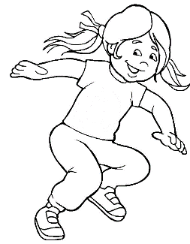

All about me

|  |
| --- |
|  |

My hair is............................................

My eyes are..........................................



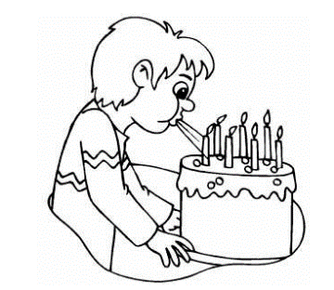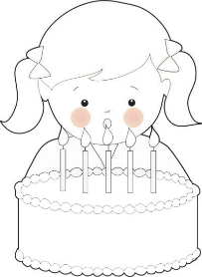

Draw candles on the birthday cake.



I am

..............................years old



Circle your birthday month.

January July

February August

March September

April October

May November

June December

My birthday is in: ..............................................................

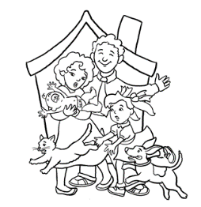

Draw or stick a photo of your family.

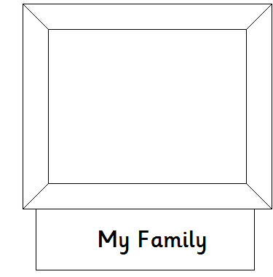

I have .......................brother/s

I have ..........................sister/s

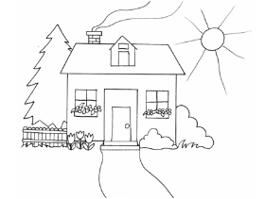

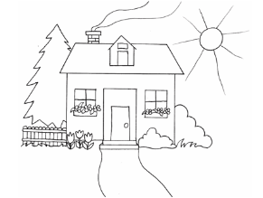Draw where you live

and write your address.

Help me to learn my address.

...............................................................

...............................................................

...............................................................



Colour the phone and write your number

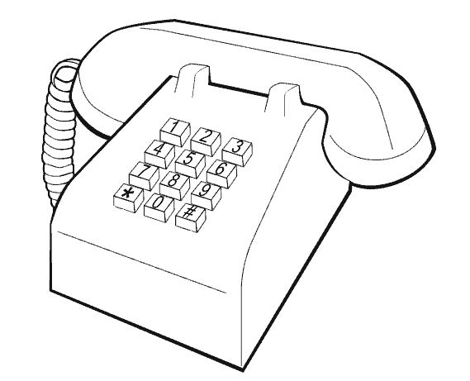

My phone number is: ................................................................

[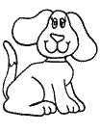](http://www.coloring.ws/t.asp?b=m&t=http://www.coloring.ws/animals/dogs/dog22.gif)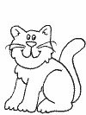

Draw or stick a picture of your family pet if you have one.

My pet’s name is ...........................

[](http://members.coloringplanet.com/gallery/cgi-bin/imageFolio.cgi?action=view&link=Food&image=eps_jello300.pdf&img=70&tt=pdf)

[](http://members.coloringplanet.com/gallery/cgi-bin/imageFolio.cgi?action=view&link=Food&image=eps_sub-sandwich.pdf&img=28&tt=pdf)Draw or stick your favourite foods.

My favourite foods are: .............................................................

............................................................

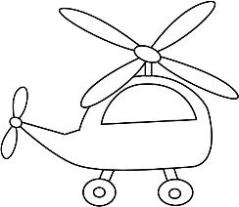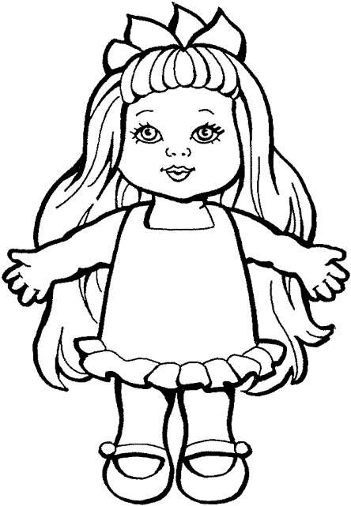

Draw your favourite toy.

Do you have a special bedtime toy?

What is it? ..........................

..........................................................



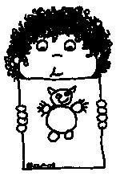

Draw a picture using your favourite colour.

This is my favourite colour

...............................................................

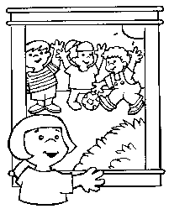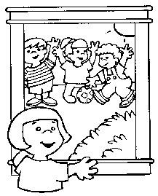

Draw your friends.

My friends are called:

...............................................................

...............................................................

...............................................................



My New Year

Today’s date is.........................................

My teacher is called:

...............................................................

I am good at:

1.............................................................

2.............................................................

3.............................................................

I am looking forward to doing:

1.............................................................

2.............................................................

3...........................................



Numbers, Shapes and Colours

** 7 8 9 10**

**6 5 1**

Can you colour in the shapes and numbers?

**2**

What colours did you use?

**4 3**

**Can you write your name?**

**6**

**----------------------------------**

**----------------------------------**

**-----------------------------------**